Published by China Association of Medical Equipment (CAMEE)
Group Standard
Implemented on 2022-07-15
Published on 2022-07-15
Specifications for Remote Radiotherapy Services

T/CAME 50 — 2022

ICS01.040.11
CCS C30

Table of Contents
Foreword III
Specifications for Remote Radiotherapy Services 4
1 Scope 4
2 Normative References 4
3 Terms and definitions 5
4 Basic Requirements for Providing Remote Radiotherapy Services 5
5 Remote Radiotherapy Service Process and Relevant Requirements 8
6 Quality Management Requirements for Remote Radiotherapy Services 12

Foreword
This document is drafted in accordance with the provisions of GB/T 1.1—2020 Directives for Standardization Part 1: Rules for the Structure and Drafting of Standardization Documents.
This document is proposed by the Radiotherapy Equipment Technology Branch of the China Association of Medical Equipment.
This document is under the jurisdiction of the China Association of Medical Equipment.
Drafting Organization of This Document:
Sun Yat-sen University Cancer Center (SYSUCC)
Peking Union Medical College Hospital (PUMCH)
Shandong Cancer Hospital
Zhejiang Cancer Hospital
Shenzhen Yino Technology Development Co., Ltd.
Southern Medical University
Neusoft Medical Systems Co., Ltd.
Shanghai United Imaging Healthcare Co., LTD.
OUR UNITED Corporation.
Foshan First People’s Hospital
Dongguan Third People’s Hospital
The Second Affiliated Hospital of Guizhou Medical University
Principal Drafters of This Document:
Chen Ming, Deng Xiaowu, Chen Li, Zhang Fuquan, Qiu Jie, Yin Yong, Gong Guanzhong, Shan Guoping, Liu Jiping, Yang Yiwei, Li Qiang, Li Jiandong, Jia Wenting, Zhou Linghong, Song Ting, Yu Xiaopeng, Liu Xin, Ni Cheng, Wang Yifeng, Zhang Zhongyuan, Lin Angchun, Huang Rong, Shi Jinping, Dong Yong, Lu Fangyang, Peng Jie.

Specifications for Remote Radiotherapy Services

1 Scope
This document specifies the basic requirements, service procedures, relevant requirements, and quality management for remote radiotherapy services (hereinafter referred to as "remote radiotherapy").
This document applies to remote radiotherapy services conducted between relevant medical institutions using information technologies such as communications, computer systems, and network technologies.

2 Normative References
The following referenced documents are indispensable for the application of this document. For dated references, only the edition cited applies. For undated references, the latest edition of the referenced document (including any amendments) applies.
- GB/T 17857-1999, Medical radiological terminology (Equipment for radiotherapy, nuclear medicine and radiation dosimetry)
- YY 0721-2009, Medical electrical equipment - Safety of radiotherapy record and verify systems (IEC 62274:2005, IDT)
- YY/T 0723-2009, Medical electrical equipment - DICOM radiotherapy objects
- YY/T 0736-2009, Medical electrical equipment - Application of DICOM in radiotherapy
- YY 0637-2013, Medical electrical equipment - Safety requirements for radiotherapy treatment planning systems
- WS/T 545-2017, Technical specifications for telemedicine information systems
- NCC/T-RT 001-2017, Basic guidelines for quality control in radiotherapy
- Ministry of Health Decree No. 46, Regulations on the administration of radiodiagnosis and radiotherapy
- National Health Commission Document No. 25 [2018], Management standards for telemedicine services (Trial)

3 Terms and definitions

For the purpose of this document, the following terms and definitions apply.
3.1
Remote Radiotherapy Service
A service where the requesting party submits an application for remote radiotherapy services (including requests for radiotherapy consultation and treatment planning for cancer patients, or quality control of radiotherapy equipment). The invited party accepts the request through the remote radiotherapy service information system and, based on the relevant materials provided by the requesting party, completes the remote radiotherapy service either offline or online, then provides feedback and archives the service results.
3.2
Remote Radiotherapy Service Cloud Platform
A cloud-based platform that utilizes modern communication, electronic, and multimedia computer technologies, integrated with the radiotherapy information management systems of both the requesting and invited medical institutions. It facilitates data collection, transmission, processing, and querying during remote radiotherapy services, as well as manages and implements the remote radiotherapy service activities between both parties. The remote radiotherapy cloud platform is managed by the invited party.

4 Basic Requirements for Providing Remote Radiotherapy Services

4.1 Institutional Requirements
4.1.1 Both the service provider (invited party) and requesting institution shall possess:
Information technology equipment and capabilities for radiotherapy data collection, transmission, recording, verification, storage, and traceability
Infrastructure meeting operational safety standards
4.1.2 Both parties shall install the remote radiotherapy cloud platform to manage service activities.
4.1.3 Both parties shall maintain dedicated facilities with:
Equipment configurations adequate for the intended remote services
Necessary multimedia devices (audio/visual systems, etc.)
4.1.4 The service provider must:
Be a Class III Grade A medical institution with valid practice licensure
Maintain ≥10 years of clinical radiotherapy service history
Possess comprehensive equipment including:
∘ Simulation/localization systems
∘ Treatment planning systems
∘ External beam and brachytherapy units
∘ Complete quality control instrumentation

4.2 Personnel Qualifications
4.2.1 The service provider shall employ:
Network/software engineers with intermediate+ professional titles
≥3 years' experience in radiotherapy informatics
4.2.2 Participating clinicians shall have:
Radiation oncologists/medical physicists with associate senior+ titles
≥8 years' clinical radiotherapy experience
4.2.3 Minimum staffing:
8+ senior radiation oncologists
2+ senior medical physicists

4.3 Technical Infrastructure
4.3.1 The remote radiotherapy cloud platform shall:
Ensure secure transmission of medical data including images, audio, text and other clinical information
Provide real-time data transfer with diagnostic-quality image resolution and data accuracy
Comply with the Technical Guidelines for Telemedicine Information Systems
Meet all clinical diagnostic and treatment requirements
4.3.2 The platform must include the following functional modules:
Patient management
Medical imaging management
Radiotherapy documentation management
Treatment planning system
Target volume contouring tools
Treatment record and verification system
Quality control workflow management
All software components shall meet NMPA (National Medical Products Administration) registration requirements for medical devices.
4.3.3 Critical infrastructure must include:
Uninterruptible power supply (UPS) for all essential equipment
24/7/365 continuous operation capability for the cloud platform
4.3.4 Network requirements:
Dual-network redundancy from at least two independent ISPs
Priority given to establishing a dedicated radiotherapy VPN where feasible
4.3.5 Server specifications:
Dedicated servers meeting all platform operational requirements
Capabilities for:
∘ Remote data backup and storage
∘ Advanced data analytics
∘ Mirror backup functionality
∘ Scalable storage capacity
4.3.6 Security architecture:
Physical isolation between internal hospital networks and external access
Industry-standard encryption protocols (e.g., AES-256) for all data transmission
4.3.7 Data protection requirements:
Comprehensive security measures for all patient data
Intuitive user interface design
Strict protocols preventing unauthorized disclosure of:
∘ Medical images
∘ Clinical records
∘ Any protected health information (PHI)
4.3.8 Information security certifications must cover:
Secure system integration and operations
Risk assessment and management
Secure software development lifecycle
Emergency response procedures
Disaster recovery and business continuity
Network security auditing

5 Remote Radiotherapy Service Process and Relevant Requirements
5.1 General Requirements
Prior to initiating remote radiotherapy services, the requesting institution (inviting party) and service provider (invited institution) shall formally execute a Remote Radiotherapy Service Agreement. This agreement must explicitly define: the scope of services, respective rights and obligations, liability allocation (particularly identifying the medical entity responsible for clinical decisions and the accountable party for treatment outcomes), data ownership, confidentiality provisions, and dispute resolution mechanisms. The agreement shall comply with relevant national healthcare regulations and telemedicine policies.
5.2 Service Content
5.2.1 Remote Radiotherapy Planning
Comprehensive services including: diagnostic review and staging confirmation, formulation of radiotherapy and integrated treatment strategies, prescription determination, target volume and organs-at-risk (OARs) delineation, treatment plan design, and plan verification/validation. All planning activities must adhere to institutional protocols and international standards (e.g., ICRU reports).
5.2.2 Remote Radiotherapy Equipment QC
Customized quality control programs addressing the requesting institution's specific equipment and departmental conditions, featuring remote review/assessment of output constancy checks, mechanical/radiation safety parameters, and dosimetric verification results. The service provider shall issue formal evaluation reports with corrective action recommendations when necessary.

5.3 Remote Radiotherapy Service Implementation Process
5.3.1 Three Parties in Remote Radiotherapy Services
5.3.1.1 Requesting Party (Primary Healthcare Institution)
The requesting party, typically a primary healthcare institution, initiates remote radiotherapy service requests through the cloud platform to higher-level medical institutions (invited parties). Upon service completion, the requesting party evaluates the results and finalizes the service request upon satisfactory evaluation.
5.3.1.2 Invited Party (Higher-Level Healthcare Institution)
The invited party, serving as the service provider, receives and processes requests from primary institutions through the cloud platform. Their responsibilities include downloading necessary patient data, performing the requested services (treatment planning or equipment QC), and uploading the final results and recommendations.
5.3.1.3 Patient Party
Patients must provide documented informed consent through the "Remote Radiotherapy Service Informed Consent Form" before any service initiation. The requesting institution is responsible for obtaining and verifying this consent.
5.3.1.4 Radiotherapy Treatment Planning Process Flow
The complete workflow for remote radiotherapy treatment planning implementation, including all participating entities and their key activities, is detailed in Figure 1.
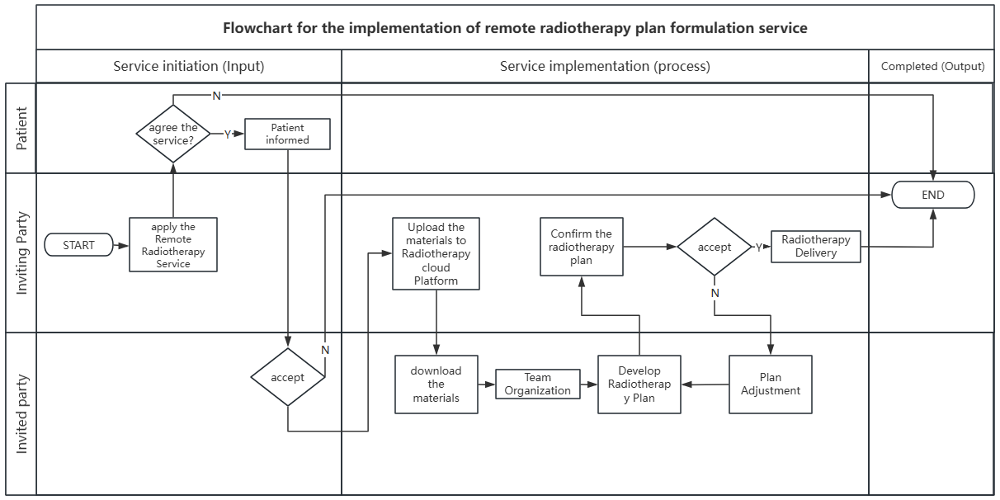
Figure 1
5.3.1.5 Remote Equipment Quality Control Process Flow
The implementation workflow for remote equipment quality control, including all participating entities and their primary activities, is illustrated in Figure 2
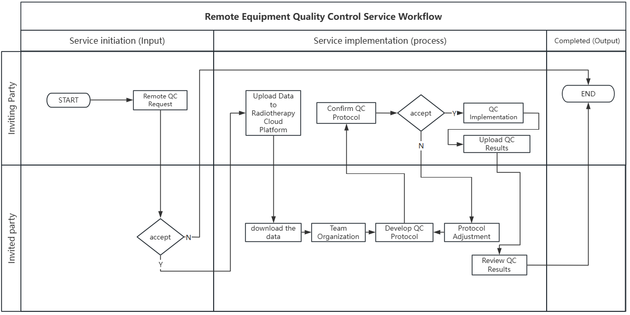 figure 2

5.3.2 Service Workflow
5.3.2.1 Initiation Phase
The requesting party submits either a treatment planning or equipment QC request through the cloud platform, accompanied by the mandatory patient informed consent documentation. The invited party then reviews and formally accepts or rejects the request based on their capacity and the case's suitability.
5.3.2.2 Implementation Phase
During this critical phase, the requesting party uploads all required clinical materials, including complete patient records, imaging data for treatment planning cases, or equipment performance data for QC requests. The invited party accesses, reviews, and processes these materials through the secure cloud platform.
5.3.2.3 Completion Phase
The service concludes with the requesting party verifying the received results, archiving all relevant data, and confirming service completion through the platform. This phase includes proper documentation of all service outcomes and any follow-up recommendations.
5.3.3 Remote Radiotherapy Treatment Planning Protocol
5.3.3.1 Specialist Selection
The requesting party, in consultation with the patient, selects appropriate radiation oncologists and medical physicists from the invited party's available specialists based on the case requirements.
5.3.3.2 Clinical Evaluation
The invited radiation oncologist conducts a comprehensive review of the patient's clinical data, verifying the diagnosis and staging accuracy, and determining the patient's suitability for radiotherapy while considering potential integrated treatment approaches.
5.3.3.3 Treatment Planning
The medical team (radiation oncologist and physicist) collaboratively develops the treatment plan, including prescription determination, target volume and OAR delineation, and technical planning. While AI-assisted tools may be employed for certain tasks, all results require professional validation and approval.
5.3.3.4 Plan Review and Finalization
The requesting party evaluates the proposed plan, engages in necessary consultations with the invited party for modifications, and ultimately approves the final treatment strategy before local implementation.
5.3.3.5 Local Verification and Implementation
The final approved plan undergoes rigorous verification at the requesting institution's facility, including dosimetric validation, before being cleared for actual patient treatment.
5.3.4 Remote Equipment QC Protocol
5.3.4.1 Physicist Selection
The requesting party identifies and engages qualified medical physicists from the invited party's resources based on their specific equipment type and departmental requirements.
5.3.4.2 QC Protocol Development
The invited physicist designs a customized quality control program addressing the specific equipment model, departmental workflow, and regulatory requirements, establishing appropriate testing parameters, methods, and frequencies.
5.3.4.3 Protocol Review and Approval
Both parties collaboratively review the proposed QC protocol, make necessary adjustments, and formally approve the final version before implementation.
5.3.4.4 Local Implementation
The requesting party's staff executes the approved QC procedures according to the established protocol and uploads the complete results dataset for remote review.
5.3.4.5 Results Validation
The invited physicist thoroughly analyzes the submitted QC data, utilizing AI-assisted tools where available (with final human verification), and provides comprehensive evaluation with recommendations for any required corrective actions.
5.4 Service Response Time Requirements
The invited party must acknowledge and provide initial response to all service requests within a strict 24-hour window from submission, ensuring timely service initiation and maintaining clinical workflow efficiency. This response timeframe represents the maximum allowable delay, with earlier responses strongly encouraged whenever possible.

6 Quality Management Requirements for Remote Radiotherapy Services
6.1 Quality Management System
Both requesting and invited institutions shall establish and implement comprehensive quality management protocols specifically tailored to their service components, with mandated periodic reviews and analyses to verify ongoing compliance and effectiveness.
6.2 Emergency Preparedness
Institutions must develop and maintain robust contingency plans with defined response mechanisms for critical incidents including data breaches, system failures, and other service disruptions that may impact patient safety or service quality.
6.3 Patient Communication Protocol
A formalized physician-patient communication framework shall be implemented to ensure: (1) complete adherence to informed consent procedures, (2) protection of patient rights and interests, and (3) full service transparency throughout all treatment phases.
6.4 Continuous Quality Improvement
Regular service evaluations shall be conducted through quantitative performance analysis and structured review meetings, with all findings systematically documented and applied for continuous service optimization and quality enhancement.

